


Prepared by:
Ahmed Musawar

1. Executive Overview 4
A. Purpose of This Manual 4
B. Network Defense Assessment 5
C. Mitigation Assessment 5
D. Incident Response Assessment 5
2. Training Manual 6
Section One: Traffic Analysis 6
A. Traffic Analysis Tools and Methodology 6
i. Packet Capturing Tools 7
ii. Alert Response Procedures 9
Section Two: Firewalls 10
B. Firewall Tools and Methodology 10
i. Rule Creation and Firewall Configuration 10
ii. Segmenting Networks 11
iii. Blocking, Allowing, and Filtering Traffic 11
iv. Implementation of Methods for Detecting Attacks 12
Section Three: Intrusion Detection and Prevention 12
C. Intrusion Detection and Prevention Tools and Methodology 13
i. Whitelisting and Blacklisting 13
ii. IDS Placement 14
iii. Monitoring, Logging (Auditing), and Alerting 14
Section Four: Vulnerability Assessment 15
D. Vulnerability Assessment Tools and Methodology 15
i. Implementation 16
ii. Identification of Weaknesses 17
Section Five: Network Assessment 19
E. Network Assessment Tools and Methodology 19
i. Processes 20
ii. Interpretation 22
Section Six: Auditing and Log Collection 23
F. Auditing and Log Collection Tools and Methodology 23
i. Company-Approved Tools 25
Section Seven: Summary of Tools 26
G. Summary of Tools 26
Section Eight: References 29

1. Executive Overview

A. Purpose of This Manual
The purpose of creating this training manual is to provide North Star Software Developers (NSSD) with a structured and practical method for strengthening its network security posture following the recent breach that exposed sensitive customer data. This manual is designed to equip IT personnel with the tools, knowledge, and best practices required to detect, prevent, and respond to threats effectively. By implementing the strategies noted in this manual, NSSD aims to protect critical assets, including customer data and proprietary software, while ensuring the confidentiality, integrity, and availability of its systems. Cybersecurity awareness training is critical in achieving these goals, as human behavior remains a key factor in many security incidents. Properly trained employees are better equipped to identify and respond to potential threats (Center for Internet Security [CIS], 2023).
This manual also supports NSSD's strategic security goals by introducing up-to-date policies, improved monitoring practices, and the adoption of industry-standard tools for intrusion detection, traffic analysis, vulnerability assessment, and incident response. These policy enhancements are done to minimize the likelihood of future breaches, improve threat detection capabilities, and reduce the impact of security incidents when they occur. Security awareness training is a proven way to significantly reduce cyber incidents, with companies reporting measurable decreases in breaches after implementing structured training programs (Fortinet, 2026). If these practices are not applied regularly, NSSD risks continued exposure to breaches, reputational damage, and financial loss. Therefore, this manual provides both the foundation and direction needed for building a resilient and proactive security environment across the organization.

B. Network Defense Assessment

Network defense processes and strategies play a critical role in securing organizational networks by creating multiple layers of protection that work together to prevent, detect, and contain threats. Effective network defense combines controls like firewalls, network segmentation, intrusion detection and prevention systems, vulnerability assessments, and continuous monitoring to minimize opportunities for unauthorized access and malicious activity. Palo Alto Networks notes that “if one line of defense is compromised or fails, subsequent layers are already in place to detect, delay, or stop an attack (Palo Alto Networks, n.d.).” Incorporating layered controls demonstrated us that relying on a single security measure creates gaps in protection, whereas combining monitoring, scanning, and access controls provides greater visibility and resilience. This approach is also called defense-in-depth strategy. This defense-in-depth approach strengthens security, limits the spread of attacks, and supports business continuity by minimizing operational risk and helping preserve customer confidence, trust, and organizational reputation.

C. Mitigation Assessment

Mitigation strategies reduce security risk by identifying and addressing vulnerabilities before they can be exploited. Some of the key mitigation activities include vulnerability assessments, patch management, least-privilege access controls, secure configurations, and network segmentation. Security assessments conducted demonstrated us that exposed services, weak configurations, and unnecessary access can significantly increase organizational risk if left unaddressed. Palo Alto Networks states that a primary goal of layered security approach is to “slow down attackers and limit lateral movement (Palo Alto Networks, n.d.).” By proactively correcting vulnerabilities and restricting access between systems, companies can contain threats more effectively and minimize the likelihood of operational disruption, data loss, and costly recovery efforts. Continuous mitigation efforts strengthen the overall security posture and enable companies to address risks before they become significant security incidents.

D. Incident Response Assessment

Incident response strategies are vital for reducing the impact of security breaches because they provide a structured approach for identifying, containing, and recovering from incidents. Effective incident response strategies include preparation, detection and analysis, containment, eradication, recovery, and post-incident review. Security monitoring and log analysis activities demonstrated us the importance of effectively identifying suspicious behavior and correlating events to determine the scope of an incident. Even with strong preventive controls in place, security breaches can still occur, which makes a well-defined response plan necessary to minimize damage and restore operations efficiently. An organized incident response plan limits downtime, improves decision-making during security breaches, and strengthens organizational resilience by reducing recovery time and improving the organization's ability to respond to future threats.

2. Training Manual

Section One: Traffic Analysis

A. Traffic Analysis Tools and Methodology
Traffic analysis is a critical network defense method used to monitor and analyze network communications for vulnerabilities, threats, and abnormal behavior. For NSSD, where a breach has already occurred, traffic analysis helps identify how the attack took place and whether it originated from an external or internal source. By examining patterns like unknown IP addresses, unusual outbound traffic, abnormal protocol usage, and unexpected data transfers, IT security personnel can detect malicious activity and develop a baseline of normal network behavior.
Effective traffic analysis combines protocol analysis and packet capturing to provide visibility into network activity. Deep packet inspection (DPI) strengthens this process by allowing security analysts to examine both packet headers and contents to detect hidden threats. As noted in the article, DPI “examines the header, the contents, and metadata associated with data packets” to uncover potential cyber threats (Keysight, 2025). This level of visibility into the network traffic enables organizations to identify anomalies more quickly and respond to potential security incidents before they escalate.

i. Packet Capturing Tools
Packet capturing tools like Wireshark are vital for identifying potential threats and vulnerabilities. Wireshark allows IT security personnel to capture network traffic, apply filters, and analyze protocols like TCP, UDP, HTTP, and FTP. Use of the features like Follow TCP Stream, the security analysts can detect suspicious behavior and reconstruct communication sessions.
By using features such as Follow TCP Stream, security analysts can detect suspicious behavior and reconstruct communication sessions. In the lab exercises, sensitive data like usernames and passwords were visible in plain text when insecure protocols were used, showing the risks of unencrypted communication. These findings highlight how packet capturing tools help identify vulnerabilities and support proactive threat detection.
The screenshots below demonstrate how packet analysis can reveal sensitive information transmitted in plain text and help analysts identify insecure communication practices.
This screenshot shows sensitive data in plain text.
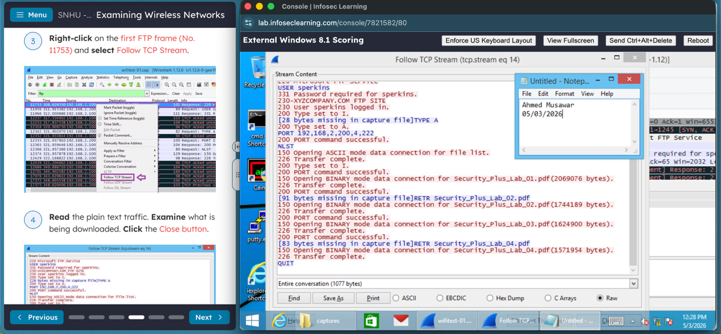
This screenshot shows the contents of the email sent using unencrypted communication channels.
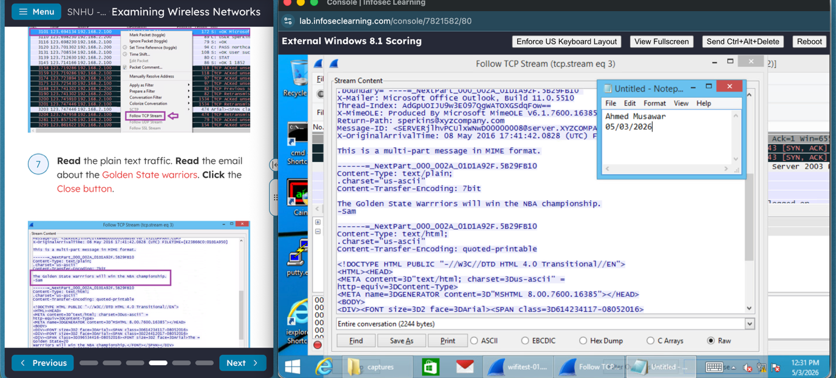
This screenshot shows user and groups that were added.
This screenshot shows the transferred files and how they can be reconstructed.
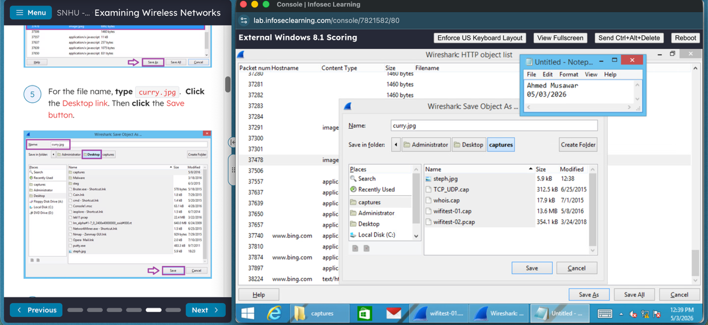

ii. Alert Response Procedures

After the anomalies are identified, planned and structured alert response procedures must always be followed to minimize the damage. The process begins with detection and validation, then followed by analysis and prioritization to determine the scope and severity of the incident.

The next step is containment, where actions like isolating affected systems and blocking malicious IP addresses are performed to prevent further spread throughout the network. According to the article, incident response aims to “identify real security incidents, get the situation under control, and limit the damage caused by an attacker” (Cynet, 2026). This well-planned approach ensures that threats are contained efficiently along with minimizing the downtime and disruption to normal business operations.

Lastly, eradication and recovery steps are performed to completely remove the threat and restore systems, followed by a post-incident review to improve future security measures. These procedures ensure that NSSD can respond quickly and efficiently, reducing the impact of future incidents.
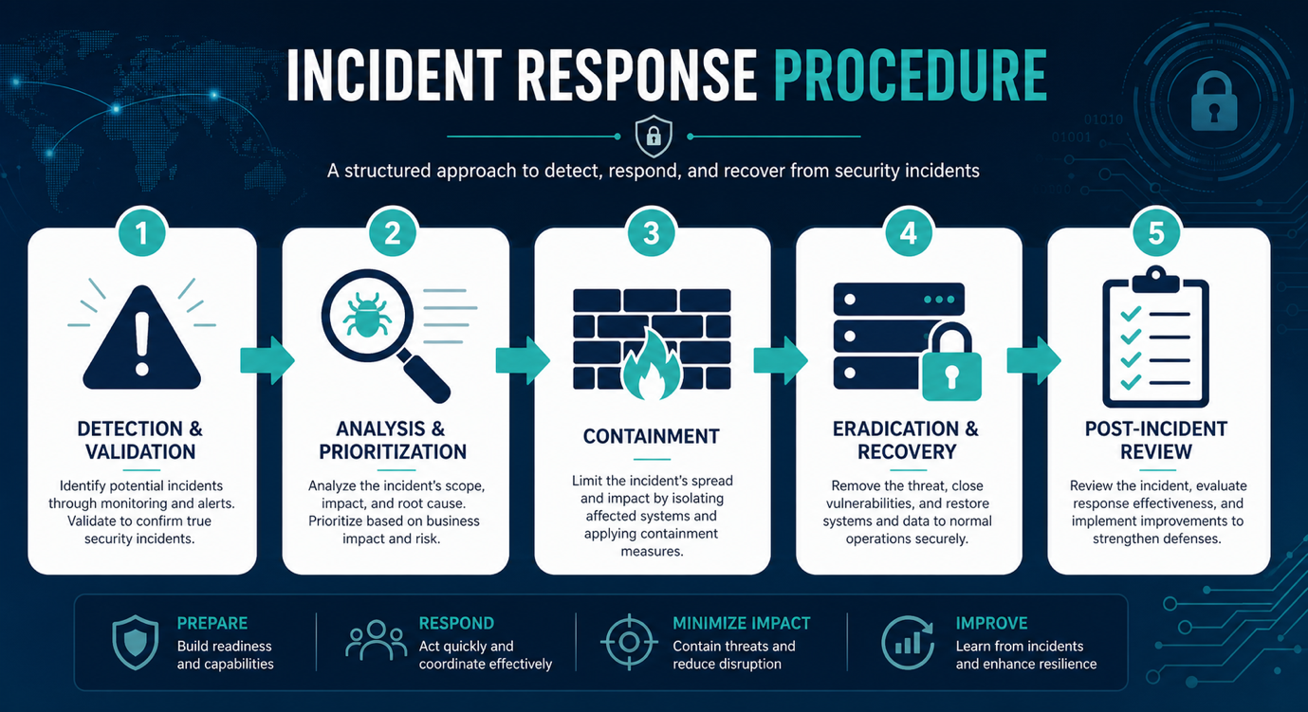

Section Two: Firewalls

B. Firewall Tools and Methodology
Firewalls are a critical component of perimeter defense which are used to control traffic between trusted internal networks and untrusted external networks. Modern firewall implementations combine multiple methods, which includes rule-based filtering, network segmentation, and continuous monitoring, to protect organizational assets. Correct configuration makes sure that only authorized traffic is allowed while limiting exposure to potential threats.

Rule Creation and Firewall Configuration

Firewall rules determine how traffic is handled based on the set criteria like IP address, port, and protocol. When developing rules, admins should first identify the services that are required for their business operations and then explicitly allow only those services.
The recommended method includes:
- Identify the needed applications and associated ports/protocols like HTTPs at port 443
- Create specific allow rules for necessary traffic like allowing HTTPs traffic via port 443 by making the rule
- Apply a default “deny all” rule for all other traffic
- Regularly reviewing and updating rules based on business needs
A key best practice is to enforce strict access control through rule design. As noted by Fortinet (n.d.), “each ACL should have a ‘deny all’ rule created at the end of it, which enables organizations to filter out unapproved traffic.” This rule makes sure that the unauthorized traffic is automatically blocked unless explicitly permitted.

Segmenting Networks

Network segmentation is a process of dividing the network into separate zones to control access between the systems. The most common zones include internal networks (LAN), external networks (WAN), and demilitarized zones (DMZ) for public-facing services.
To implement segmentation:
- Define network zones based on their function and associated risks
- Assign IP ranges and map them to firewall interfaces to create segments
- Apply rules to control communication between the zones
- Restrict access using the least privilege principle
Segmentation provides better security by limiting the spread of attacks, isolating critical systems, and reducing the attack surface area. According to CompTIA (2024), “systems and services need to be isolated from each other in order to prevent a minor breach from becoming a significant security incident.” This method reduces lateral movement and protects sensitive data.

Blocking, Allowing, and Filtering Traffic

Firewalls are used to manage traffic by applying the rules that determine whether the data should be allowed or blocked. These decisions are based on defined criteria like source and destination IP addresses, ports, and protocols.
Best practices include:
- Blocking unnecessary ports and insecure services
- Allow only required applications and traffic
- Filter traffic using specific and well-defined rules
As discussed earlier, inbound traffic should be denied by default unless it is explicitly allowed, while the outbound traffic should be checked and restricted as needed. This method ensures secure and controlled network communication without disrupting business operations.

Implementation of Methods for Detecting Attacks

Effective and proper firewall implementation requires continuous monitoring and detection of potential threats. Firewalls provide visibility into network activity through logging and alerting mechanisms (SIEM).
Recommended best practices include:
- Enable firewall logs and regularly review them
- Monitor traffic for unusual patterns or unauthorized access attempts
- Use network scanning tools to validate configurations
- Implement IDS and IPS mechanisms where available
Continuous monitoring allows admins to effectively identify and respond to potential security incidents. Integrating firewall logs with centralized monitoring systems further enhances visibility and strengthens the organization’s overall security posture.

Section Three: Intrusion Detection and Prevention

C. Intrusion Detection and Prevention Tools and Methodology

Intrusion Detection and Prevention Systems (IDS/IPS) are used to identify suspicious behavior, monitor network activity, and provide or support response to potential threats. An IDS primarily focuses on detection and alerting, whereas an IPS can actively block malicious traffic and prevent attacks. These tools are used to identify reconnaissance activities, unauthorized access attempts, and anomalies within the network. According to NIST, IDS/IPS tools use multiple methods to detect traffic such as signature-based and anomaly-based techniques to improve accuracy (Scarfone & Mell, 2007). In secure systems, these tools work together to provide visibility into network activity and support faster incident response to reduce the system downtime in case of breaches.

i. Whitelisting and Blacklisting

Whitelisting and blacklisting are both methods to control traffic. They tell which traffic is allowed or denied within the network. Blacklisting blocks known malicious activity like specific users, files, or patterns, while whitelisting allows only trusted activity and reduces false positives. A whitelisting approach is generally more secure because it blocks all activity except traffic that is explicitly authorized. In practicality, the IDS/IPS tools like Snort use rule-based configurations to identify and control traffic. These rules decide what should be flagged or ignored based on known behaviors and patterns.
This screenshot shows how Snort rules configured to detect specific user activity and malicious file patterns.
Companies should configure rules based on sensitive accounts, known threats, and critical resources. Blacklists should be kept up to date, while whitelists must only include verified and necessary traffic.

ii. IDS Placement
Proper IDS placement is critical to ensure visibility across the network. The sensors should be configured at key locations like network boundaries, internal segments, and near critical/sensitive systems to monitor both inbound and outbound traffic. Malicious actors often begin with reconnaissance techniques, including port scanning, to identify open services that may be exploited.
This screenshot gives visibility into how an Nmap scan shows open ports and services on the target system.
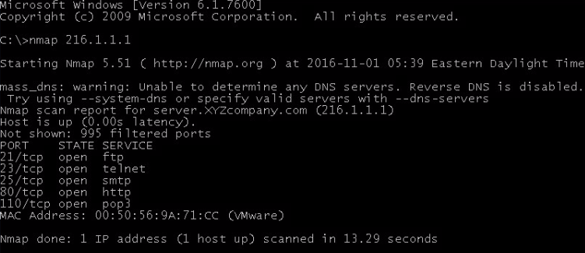
To support detection, tools like tcpdump are also used to capture traffic directly from network interfaces (eth0/eth1) for analysis. This screenshot shows tcpdump capturing live traffic from a network interface for monitoring purposes.
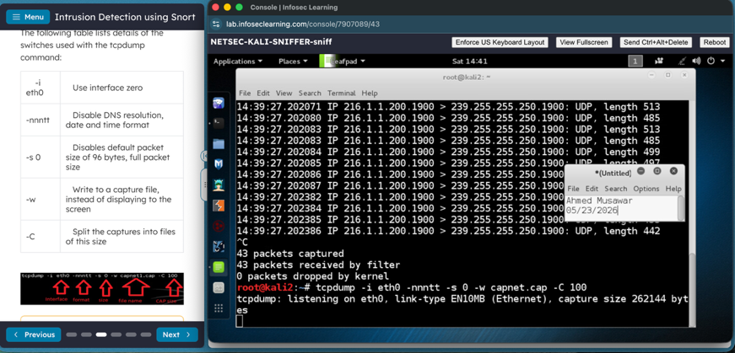
IDS sensors must be placed where they can observe high-value and critical traffic, especially between internal and external networks. Monitoring multiple network segments improves detection capabilities and limits blind spots.

iii. Monitoring, Logging (Auditing), and Alerting
Monitoring, logging, and alerting are critical functions of IDS/IPS, as these tools help detect and respond to threats. By using these tools, we continuously track activity, store logs, and generate alerts when suspicious patterns are detected. Logs are also crucial as they provide visibility into events like repeated login attempts or unusual access behavior, which could indicate potential attacks. These logs support both real-time response and later analysis of the breach.
This screenshot gives visibility into how Snort alert file shows detected suspicious activity and repeated login attempts.
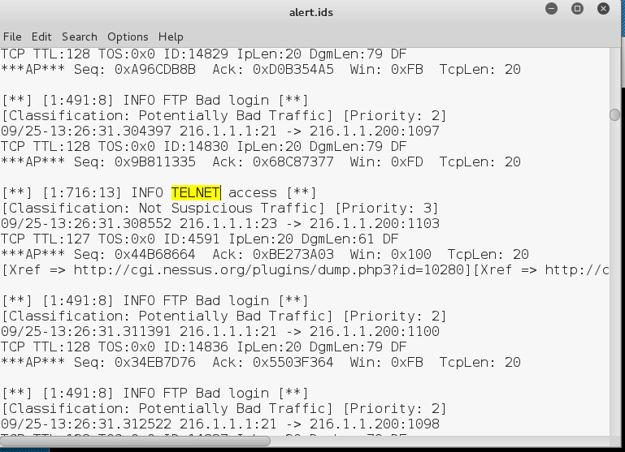
Companies should regularly review logs and prioritize the alerts based on their severity. Maintaining proper logging and alerting systems ensures the timely detection of breaches and supports incident response efforts.

Section Four: Vulnerability Assessment

D. Vulnerability Assessment Tools and Methodology
Vulnerability assessment helps companies identify weaknesses before threat actors can exploit them. Even with firewalls and intrusion detection systems in place, vulnerabilities like open ports, outdated software, and weak configurations can still expose systems and networks to risk. IBM explains that vulnerability scanning is the process of evaluating and analyzing systems for weaknesses that malicious actors may exploit (IBM, n.d.). Tools like Nmap, Zenmap, and OpenVAS allow IT personnel to automate security vulnerability assessments and strengthen overall network protection.

i. Implementation
Proper implementation of network vulnerability assessments includes port scanning, device scanning, and penetration testing techniques. The security personnel can use Nmap to identify open ports, detect services, and gather operating system information. Zenmap provides a graphical interface (GUI) for analyzing and observing scan results, while OpenVAS performs deeper vulnerability analysis by comparing systems against known vulnerability databases like NVD website. StarLearn (2022) explains that “OpenVAS is a free tool to use and can be quite comprehensive in its scanning techniques as well as assisting in finding vulnerabilities.” This makes OpenVAS an effective tool for regularly scheduled assessments.
Companies should conduct both authenticated and unauthenticated vulnerability scans. IBM (n.d.) notes that vulnerability scanners support security teams in identifying weaknesses via automated recurring assessments, allowing risks and vulnerabilities to be discovered and addressed proactively.
Figure 1. Nmap protocol scan identifying active network protocols and exposed services on the target host.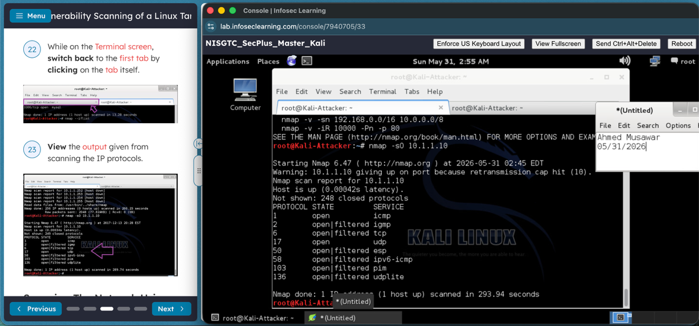
Figure 2. Zenmap host discovery results displaying identified devices and open service ports.
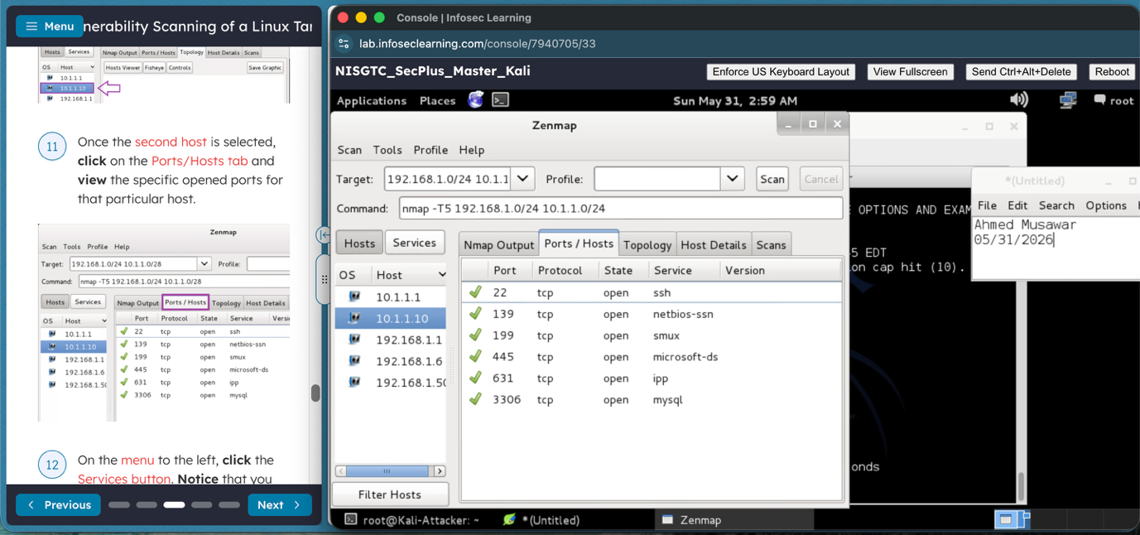
Figure 3. OpenVAS scan scheduling configuration for recurring automated vulnerability assessments.
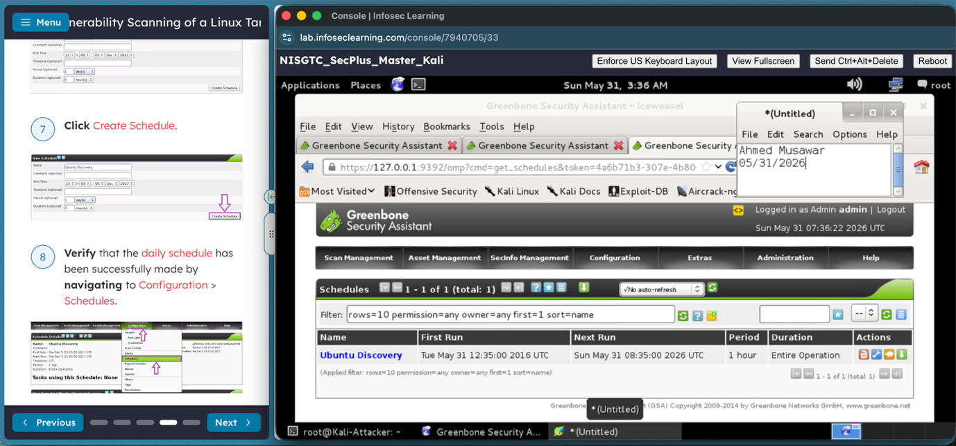

ii. Identification of Weaknesses
Scan output must be carefully reviewed and analyzed to identify unnecessary open ports, outdated software, weak configurations, and critical vulnerabilities. IBM (n.d.) notes that advanced vulnerability scanners prioritize findings based on the severity of risks, which help administrators focus remediation efforts on the highest-risk issues first. Severity ratings and associated CVEs show important information for determining which weaknesses require immediate action.
OpenVAS reports must also be reviewed after all the updates or security changes to verify that remediation efforts were successful. As StarLearn (2022) explains, “scanning a device once is not enough to confirm that it has passed all the tests.” Regular scans help validate security improvements and confirm that critical systems are always protected. By interpreting scan results correctly, security personnel can minimize the attack surface and support continuous vulnerability management.
Figure 4. OpenVAS vulnerability scan report showing detected weaknesses ranked by severity.
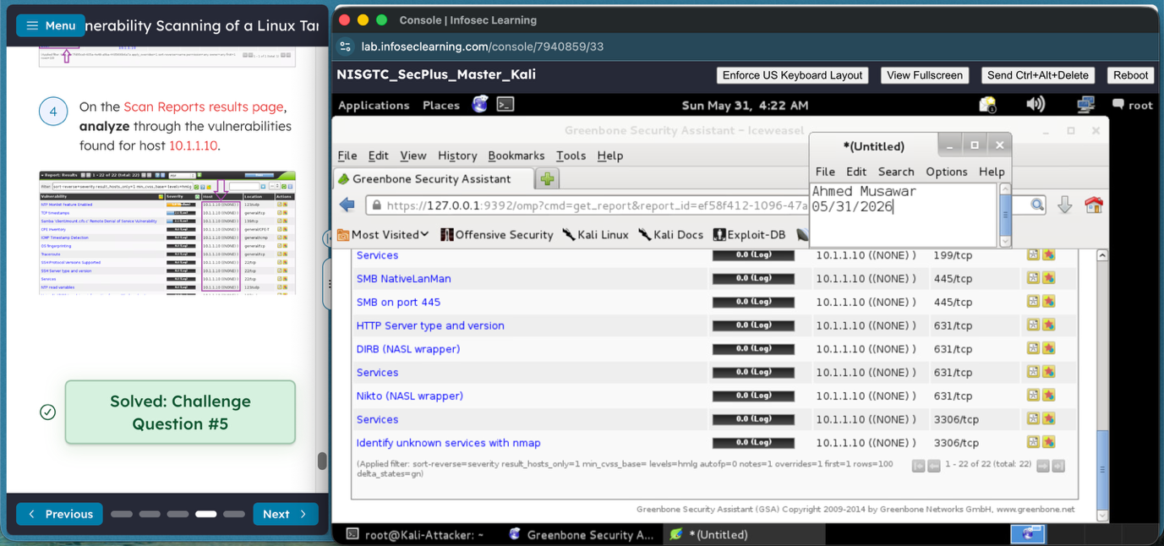
Figure 5. Common Vulnerabilities and Exposures (CVE) database output used to analyze identified security risks.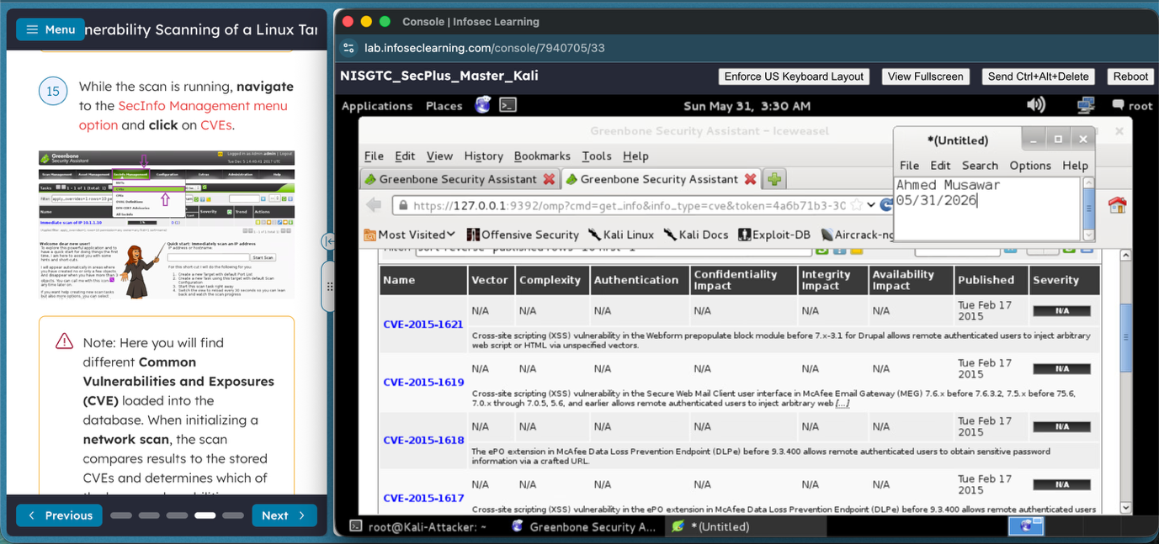

Section Five: Network Assessment

E. Network Assessment Tools and Methodology
Network assessment is the method of identifying devices, services, connections, and vulnerabilities within a network environment. Common tools used for network assessment are Nmap, Zenmap, and Armitage. These tools help security teams in discovering active hosts, identifying open ports, detecting unauthorized devices, mapping network topologies, and assessing potential security risks. According to Dean, “understanding what’s on the network is often the first step in protecting it” (Dean, 2023). Network assessments must be conducted regularly as part of a risk-based security program to maintain visibility and finding vulnerabilities before they can be exploited and cause damages to the systems.

i. Processes
The network assessment process begins with host discovery to identify all devices connected to the network which is also called reconnaissance. Tools like ARP Scan and Nmap are used to locate active systems and create a list of authorized devices. Any device which we cannot match to approved network assets must be investigated as a potential rogue device.
After hosts are discovered, port and service scanning must be performed to find running services and exposed ports. Open ports could indicate unnecessary services, misconfigurations, or potential attack vectors. Service detection and OS identification provide additional information that can be used to evaluate risk.
Network topology analysis should then be done using tools like Zenmap or Armitage to visualize relationships between hosts and identify network vulnerabilities. Topology mapping assists security personnel in understanding how systems communicate and highlights areas where segmentation or access controls may be insufficient.
Malicious connections could be identified by analyzing scan results for unexpected or rogue services, unauthorized remote access protocols, unusual communication paths, or systems exposing sensitive services to the network. Lansweeper notes that “every unknown device in your network presents an opportunity for exploitation” (Libeer, 2025), highlighting the importance of continuous monitoring for rogue devices and unauthorized connections.
ARP scan used to discover active hosts and devices on the local network.

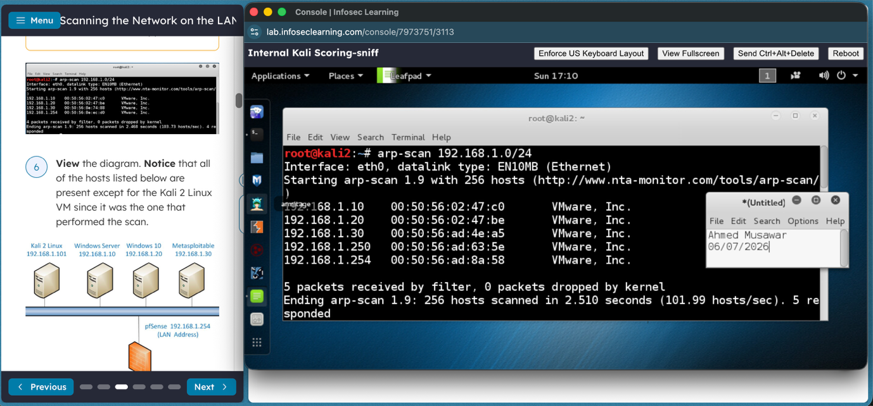
Nmap TCP scan identifying open ports and services on a target host
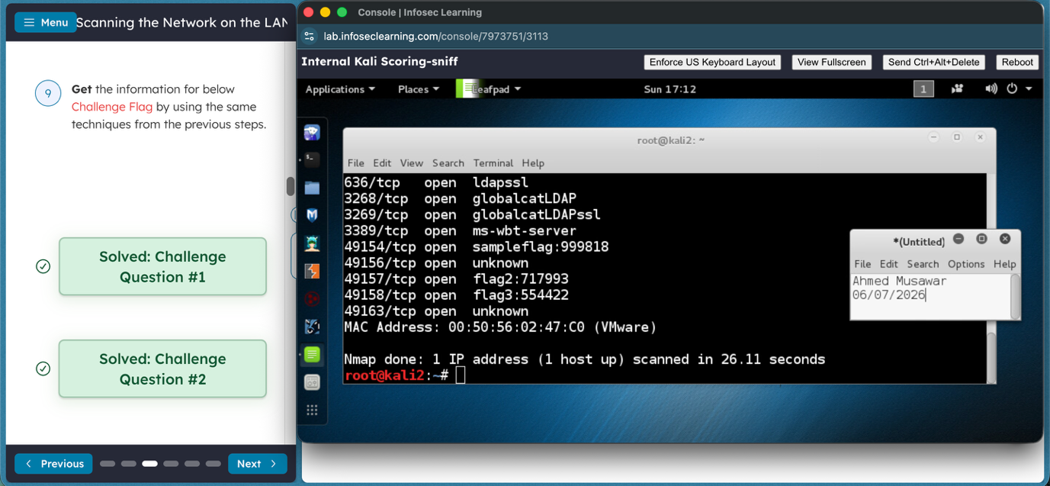
Zenmap scan results displaying discovered hosts and network assessment information
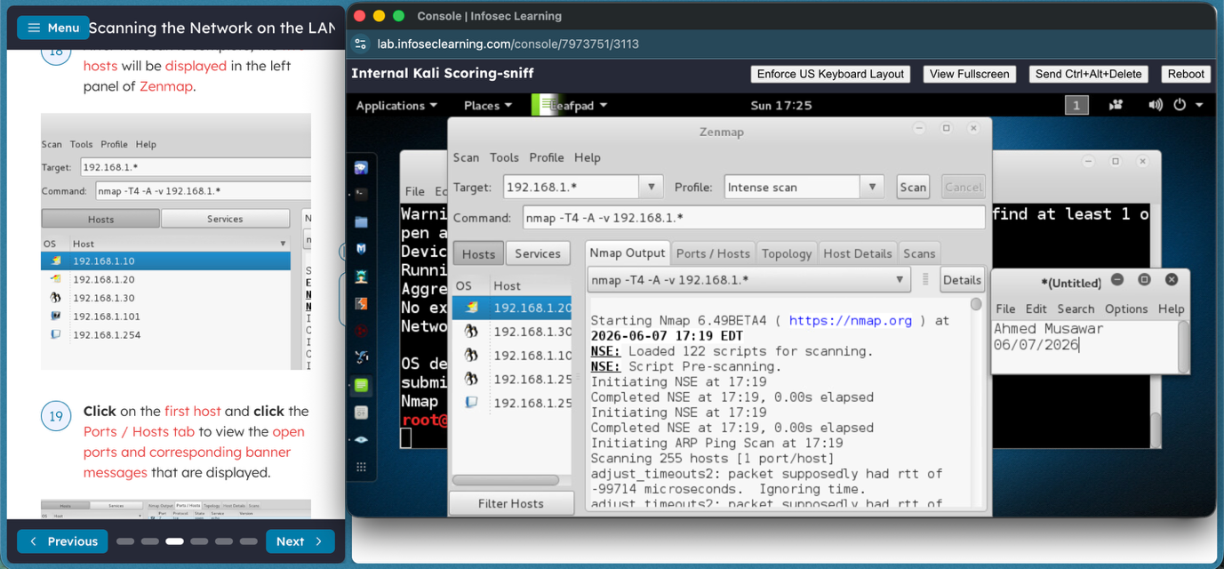
Armitage host enumeration used to identify systems and potential attack paths within the network.
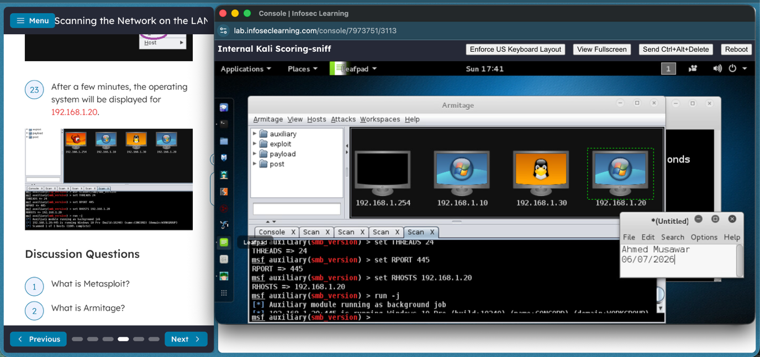

ii. Interpretation
Network scan results should be analyzed to find systems that pose security risks. Hosts that show up unexpectedly on the network could indicate unauthorized or rogue devices. Open ports must be evaluated to determine whether the identified services are needed for business operations. Services that are unnecessary or outdated must be disabled or fixed.
Operating system detection scans should also be analyzed to identify unsupported or unpatched systems that could contain known vulnerabilities which can pose a security risk. Service banners and version information can also help in identifying outdated applications that need updates.
Topology and assessment results should be reviewed to find systems with excessive exposure, weak segmentation, or unnecessary connectivity. Devices that expose multiple services, use insecure protocols, or allow unauthorized access must be prioritized for remediation. By continuously reviewing network assessment scan results, companies can minimize their attack surface, improve visibility, and strengthen overall network security posture.
Nmap operating system detection used to identify host characteristics and system types.
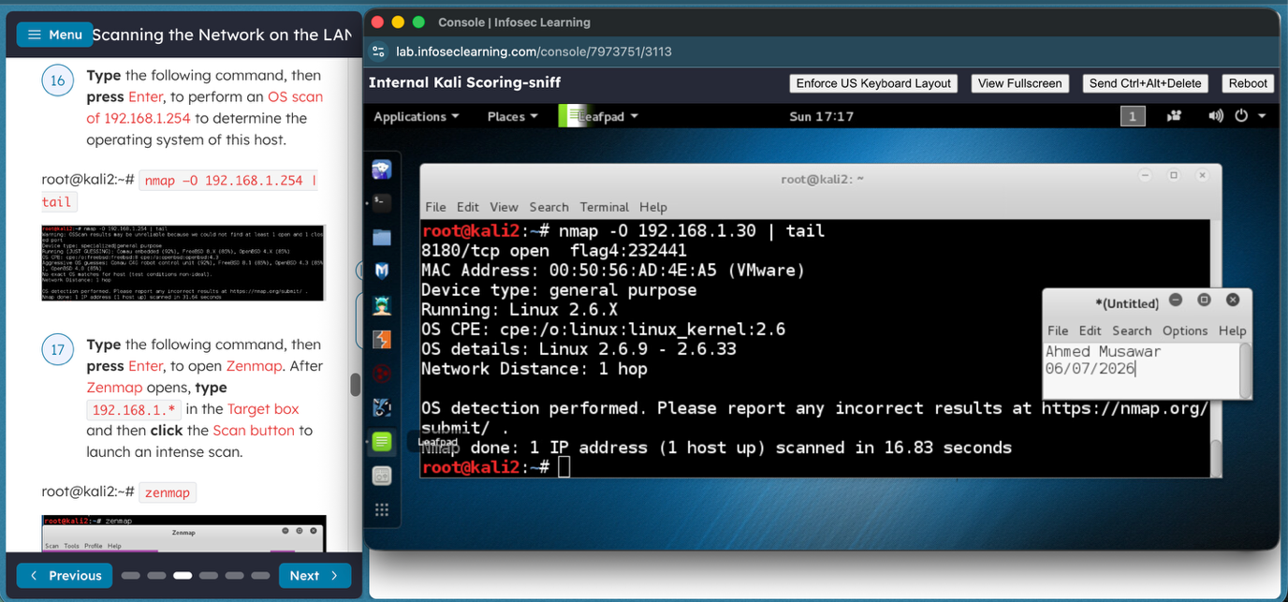
Armitage visualization showing successful compromise of discovered hosts during security assessment testing.
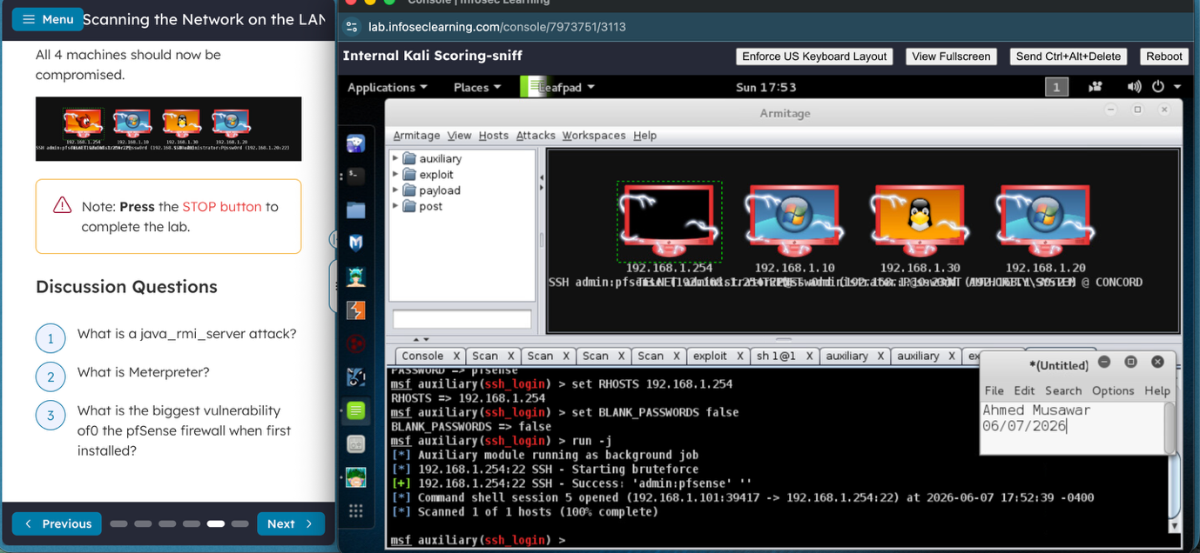

Section Six: Auditing and Log Collection

F. Auditing and Log Collection Tools and Methodology
Auditing and log collection are important components of any company's security program as they provide visibility into system activity, support incident investigations, and help organizations maintain compliance requirements. NSSD should implement centralized logging and continuous monitoring to make sure that security events are collected, analyzed, and retained for future review. Effective auditing requires gathering information like user logins, failed authentication attempts, account modifications, configuration changes, network activity, vulnerability findings, and security alerts. According to Fortra, “Comprehensive Coverage: Make sure logs capture appropriate and crucial data such as user IDs, timestamps, event types, affected resources, and outcomes of events” (Fortra, 2024). Logs must be collected from systems, applications, servers, and network devices and sent to a centralized repository where they can be monitored and reviewed. Additionally, synchronized timestamps must be maintained across all the systems to help in accurate event correlation, incident response, and forensic investigations.
Snort configured for inline IPS operation using DAQ modules to detect and prevent malicious network activity.
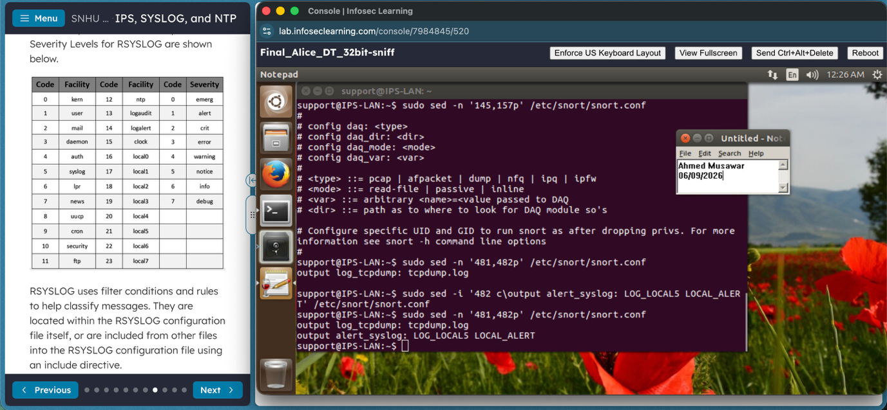
Snort configured to forward security alerts to a centralized Syslog server for monitoring and analysis.
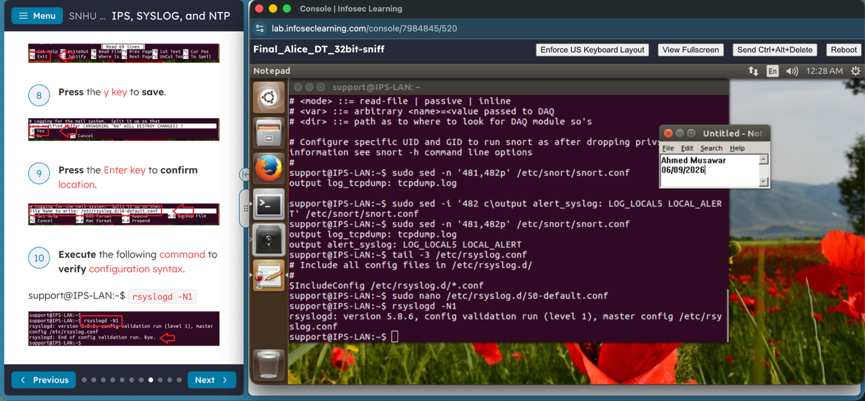
Network Time Protocol (NTP) configuration used to synchronize timestamps across systems and improve log correlation.
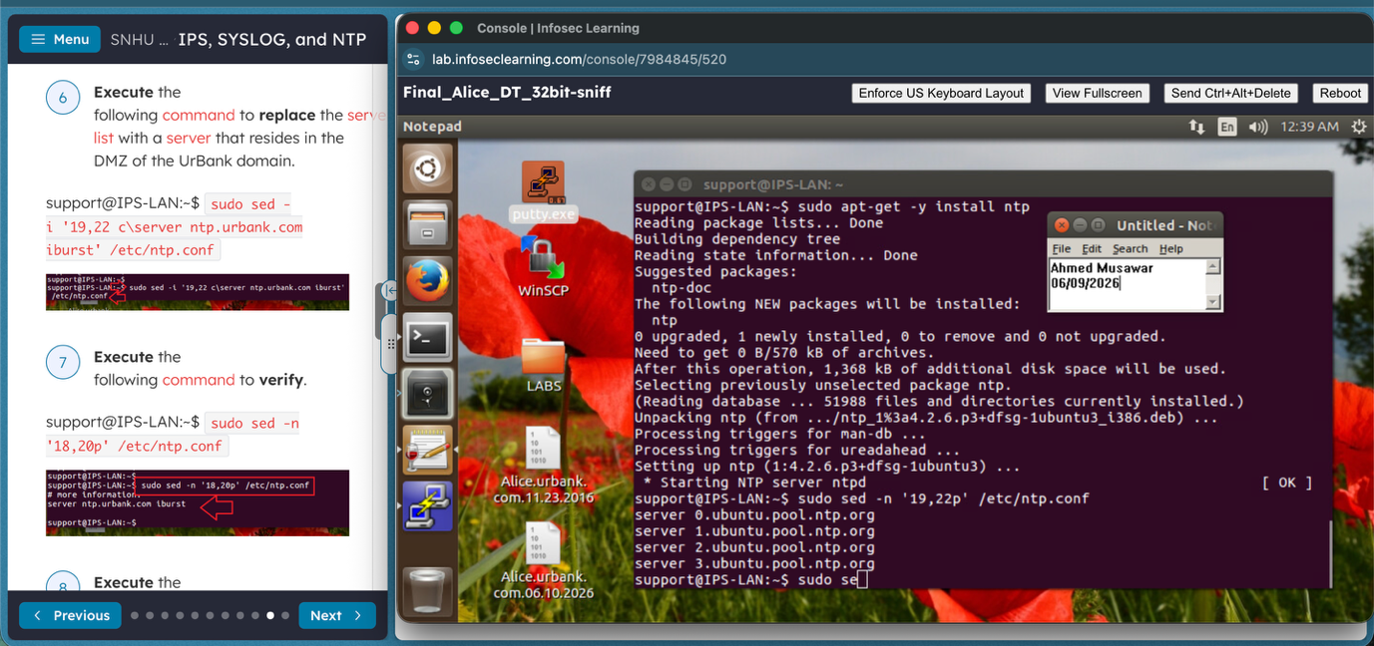

i. Company-Approved Tools
NSSD must approve a combination of security monitoring, logging, and auditing tools which will strengthen visibility across the company and improve incident response capabilities. A Security Information and Event Management (SIEM) tool like Microsoft Sentinel should be incorporated to aggregate logs, correlate events, and generate real-time security alerts from multiple sources. Tools like Syslog should be used to centralize logs from servers, endpoints, applications, and network devices, which will allow security personnel to efficiently review and retain audit data. Snort IPS must be implemented to detect and prevent malicious network activity while generating alerts that aids in threat detection and investigation efforts.
Nessus should also be used to perform vulnerability assessments and identify security weaknesses before threat actors are able to exploit them. Nmap should be approved by the organization for network discovery and asset identification to help in maintaining an accurate inventory of devices and services operating within the system. NTP must be used to synchronize timestamps across all systems to make sure audit logs remain accurate and reliable during investigations. As Red Canary article explains, “A Security Information and Event Management (SIEM) system is a foundational component of most SOCs” (Red Canary, 2025). These tools were selected because they provide centralized log management, vulnerability identification, threat detection, network visibility, and accurate event tracking. These components are vital for maintaining a strong security posture and supporting organizational compliance requirements.

Section Seven: Summary of Tools

G. Summary of Tools
NSSD should focus on implementing a layered security strategy which combines auditing, monitoring, vulnerability assessment, and threat detection technologies. Relying on only one security tool creates visibility gaps and increases organizational risk. According to Red Canary, “A SOC relies on a suite of specialized tools and technologies that work in concert to provide comprehensive security monitoring, threat detection, and incident response capabilities” (Red Canary, 2025). By incorporating multiple security tools, companies can improve their ability to identify, investigate, and respond to security threats.
Some of the vital tools recommended for NSSD are Microsoft Sentinel, Syslog/RSYSLOG, Snort IPS, Nessus, Nmap, NTP, and password auditing tools like Hydra or John the Ripper. Microsoft Sentinel gives centralized monitoring and event correlation, while Syslog aids in log collection and retention. Snort helps detect and prevent malicious system activity, and Nessus identifies vulnerabilities requiring remediation. Nmap helps with network discovery and asset identification, while NTP ensures logs remain synchronized across systems. Password auditing tools help identify weak credentials and strengthen authentication controls.
Combined, these tools provide comprehensive support for network monitoring, auditing, vulnerability management, incident response, and security operations. Their simultaneous use enables NSSD to maintain a proactive security posture, reduce risk, and improve the organization's ability to respond to emerging threats. Network discovery and asset identification capabilities provided by Nmap are illustrated in Section Five and support ongoing auditing and security assessment activities.
Password auditing tool used to identify weak credentials and improve authentication security.
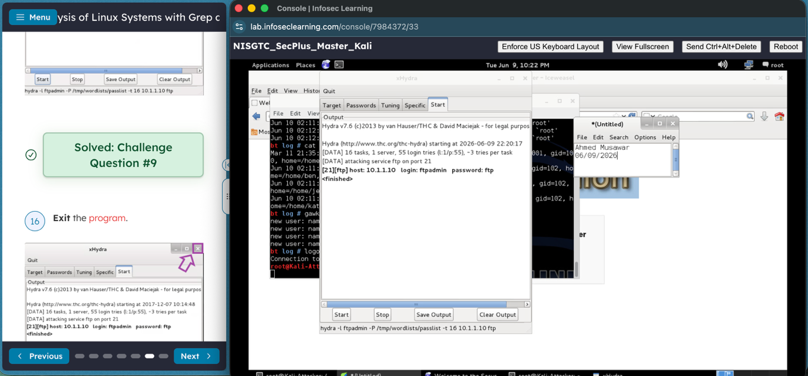
Network discovery and port enumeration results used to identify assets and support security assessments.
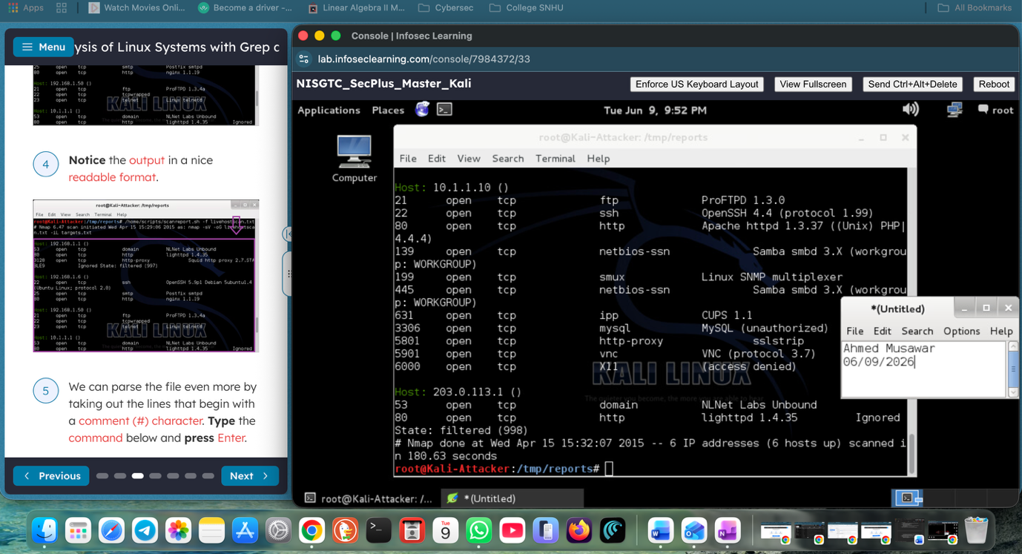

Section Eight: References
Center for Internet Security. (2023). Why employee cybersecurity awareness training is important.
https://www.cisecurity.org/insights/blog/why-employee-cybersecurity-awareness-training-is-important
CompTIA. (2024, November 13). What is network segmentation and why does it matter?
https://www.comptia.org/en-us/blog/what-is-network-segmentation-and-why-does-it-matter/
Cynet. (2026, April 10). Incident response management: Key elements and best practices.
https://www.cynet.com/security-foundations/incident-response/incident-response-management-key-elements-and-best-practices/
Dean, M. (2023, September 15). Understanding Nmap network scanning, a core cybersecurity tool. Cyberbit. https://www.cyberbit.com/security-operations/understanding-nmap-network-scanning/
Fortinet. (n.d.). Firewall configuration.
https://www.fortinet.com/resources/cyberglossary/firewall-configuration
Fortinet. (2026, March 4). 2025 security awareness report: Why training works and where organizations still fall short.
https://www.fortinet.com/blog/industry-trends/2025-security-awareness-report-why-training-works-and-where-organizations-still-fall-short
Fortra. (2024, May 13). Audit log best practices for security & compliance. Fortra. https://www.fortra.com/blog/audit-log-best-practices-security-compliance
IBM. (n.d.). What is vulnerability scanning? IBM. https://www.ibm.com/think/topics/vulnerability-scanning
Keysight. (2025, April 30). Network visibility and deep packet inspection (DPI) deliver better threat detection together.
https://www.keysight.com/blogs/en/tech/nwvs/network-visibility-and-deep-packet-inspection-dpi-deliver-better-threat-detection-together
Libeer, L. (2025, February 13). Detecting rogue devices: The modern approach. Lansweeper. https://www.lansweeper.com/blog/itam/detecting-rogue-devices-the-modern-approach/
Palo Alto Networks. (n.d.). What is defense-in-depth? https://www.paloaltonetworks.com/cyberpedia/what-is-defense-in-depth
Red Canary. (2025). Essential security operations center (SOC) tools and technologies. Red Canary. https://redcanary.com/cybersecurity-101/security-operations/soc-tools
Scarfone, K., & Mell, P. (2007). Guide to intrusion detection and prevention systems (IDPS) (NIST SP 800-94). National Institute of Standards and Technology. https://tsapps.nist.gov/publication/get_pdf.cfm?pub_id=901146
StarLearn. (2022, September 21). NMAP: Threats—vulnerability scanning. Medium. https://starlearn.medium.com/nmap-threats-vulnerability-scanning-59671dbdb1ce

